Add **FullAccess** for a Mailbox without Automapping

* How to connect with Powershell (Exchange/Msol)
* Preparing the CSV file
* remove FullAccess + add FullAccess without automapping
* list access rights for SCV  
    
  Script requires **%userprofile%\Documents\automapping.CSV**

1st column **Indentity** (accessed *mailbox*)

2nd column **User** (*accessing user*)

**First step for all bulk scripts below:**

* Import the data for **Identity, User** from **CSV file** under

%userprofile%\**Documents\automapping.CSV**

$automapping = Import-Csv $ENV:UserProfile\Documents\automapping.CSV

Add FullAccess for a Mailbox without Automapping

* remove prior FullAccess + add new FullAccess without automapping  
    
  *\*copy/paste the below script and insert into Powershell*

$automapping | ForEach-Object { Remove-MailboxPermission -Identity $_.Identity -User $_.User -AccessRights FullAccess -Confirm:$false | Add-MailboxPermission -Identity $_.Identity -User $_.User -AccessRights FullAccess ​-AutoMapping:$false }​

* list access rights for CSV

$automapping | ForEach-Object { Get-MailboxPermission -Identity $_.Identity -User $_.User }​

* Remove 1

remove-MailboxPermission -Identity accessed@mailbox.com -User accessing@user.com -AccessRights FullAccess -Confirm:$false

* Add 1

Add-MailboxPermission -Identity accessed@mailbox.com -User accessing@user.com -AccessRights FullAccess ​-AutoMapping:$false

* Remove only from CSV

$automapping | ForEach-Object { Remove-MailboxPermission -Identity $_.Identity -User $_.User -AccessRights FullAccess -Confirm:$false }​​

* Add from CSV

$automapping | ForEach-Object { Add-MailboxPermission -Identity $_.Identity -User $_.User -AccessRights FullAccess ​-AutoMapping:$false }​

* remove prior FullAccess + add new SendAs without automapping from CSV

$automapping | ForEach-Object { Remove-MailboxPermission -Identity $_.Identity -User $_.User -AccessRights FullAccess -Confirm:$false | Add-MailboxPermission -Identity $_.Identity -User $_.User -AccessRights SendAs ​-AutoMapping:$false }​

* Preparing the CSV File

\**Make sure the used file is saved as* **CSV Comma separated**

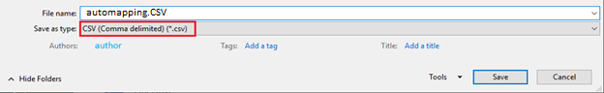

The data will look like this

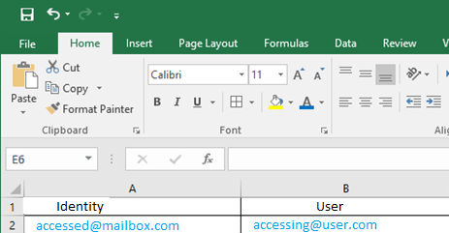

In Notepad …

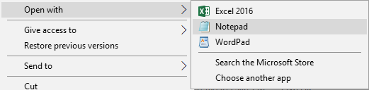

.. it will look like this

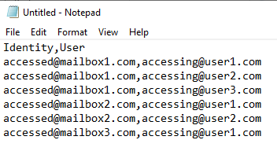

CSV template format

|  |  |
| --- | --- |
| Identity | User |
| accessed@mailbox.com | accessing@user.com |

below the TXT template format

Identity,User  
accessed@mailbox1.com,accessing@user1.com  
accessed@mailbox1.com,accessing@user2.com  
accessed@mailbox1.com,accessing@user3.com  
accessed@mailbox2.com,accessing@user1.com  
accessed@mailbox2.com,accessing@user2.com  
[accessed@mailbox3.com,accessing@user1.com](mailto:accessed@mailbox3.com,accessing@user1.com)

How to connect with Powershell (Exchange/MSOL)

* Download 64 Bit Version [PowerShell-6.2.2-win-x64.msi](https://github.com/PowerShell/PowerShell/releases/download/v6.2.2/PowerShell-6.2.2-win-x64.msi)  
    
  **Get**-Host | Select-Object **Version**
* 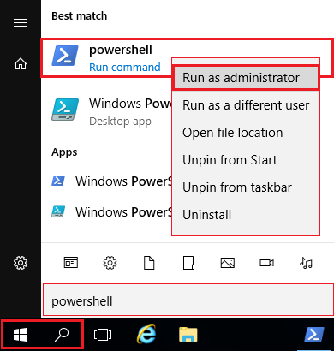[*Official Documentation: Connect to Powershell*](https://docs.microsoft.com/en-us/powershell/exchange/exchange-online/connect-to-exchange-online-powershell/connect-to-exchange-online-powershell)  
    
  *Below is not officially supported*

*Only provided “as is” for your convenience*

* All-in-One
* First time only
* Step by step

All-in-One

|  |  |  |
| --- | --- | --- |
|  |  |  |
|  | Set-ExecutionPolicy RemoteSigned –Force |  |
|  |  |  |
|  | Get-Credential "*YOUR_ADMIN@DOMAIN.COM*" | Export-Clixml $ENV:UserProfile\Documents\MyCredential.xml |  |
|  | *\*Stores encrypted password under* ***%userprofile%\Documents\MyCredential.xml*** |  |

* copy below directly
* Alternative save as .TXT and rename .PS1
* Then type .\log.PS1 to connect to EXO / MSOL

|  |  |  |
| --- | --- | --- |
|  |  |  |
|  | $cred = Import-Clixml $ENV:UserProfile\Documents\MyCredential.xml |  |
|  |  |  |
|  | Connect-MsolService -Credential $cred |  |
|  |  |  |
|  | $Session = New-PSSession -ConfigurationName Microsoft.Exchange -ConnectionUri <https://outlook.office365.com/powershell-liveid/> -Credential $cred -Authentication Basic -AllowRedirection |  |
|  |  |  |
|  | Import-PSSession $Session –DisableNameChecking |  |
|  |  |  |



* Type ”**Powershell**” near Start Menu
* search will open
* **right-click** the appearing Powershell icon
* choose "Run as **Administrator**"
* It should look like this

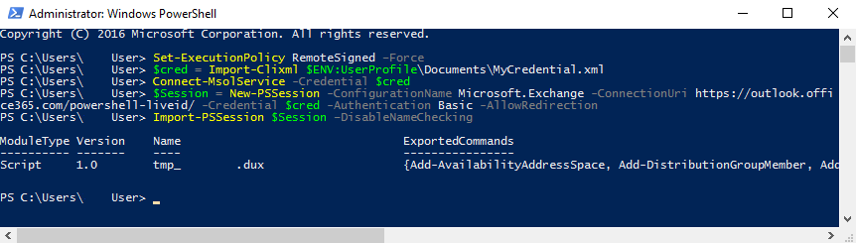

*If not successful, make sure that you are logged in with:*

* Admin
* correct password
* MFA disabled
* outdated Powershell Version *see above
* First time only

Powershell Download 64 Bit [PowerShell-6.2.2-win-x64.msi](https://github.com/PowerShell/PowerShell/releases/download/v6.2.2/PowerShell-6.2.2-win-x64.msi)

Check the installed Powershell version:

**Get**-Host | Select-Object **Version**  
Below is not supported, only provided “as is” for your convenience

[Official Documentation to connect to Powershell for reference](https://docs.microsoft.com/en-us/powershell/exchange/exchange-online/connect-to-exchange-online-powershell/connect-to-exchange-online-powershell)

* *Allow signed scripts – the* **-Force** *parameter will skip Y/N confirmation*

### **Alternative**: Allow ***unsigned*** scripts with: *Set-ExecutionPolicy* **Bypass** *–Force*

|  |  |  |
| --- | --- | --- |
|  |  |  |
|  | Set-ExecutionPolicy RemoteSigned –Force |  |
|  |  |  |

#### modify below to your **ADMIN login** ##########################

#### only enter your credentials once and stored encrypted #####

#### located under **%userprofile%\Documents\MyCredential.xml** ####

|  |  |  |
| --- | --- | --- |
|  |  |  |
|  | Get-Credential "*YOUR_ADMIN@DOMAIN.COM*" | Export-Clixml $ENV:UserProfile\Documents\MyCredential.xml |  |
|  |  |  |

* Step by step

**you can save the below in a TXT file and change it to log.PS1**

**then put the File in current dir and run as .\log.PS1**

* read out credentials from **%userprofile%\Documents\MyCredential.xml**

|  |  |  |
| --- | --- | --- |
|  |  |  |
|  | $cred = Import-Clixml $ENV:UserProfile\Documents\MyCredential.xml |  |
|  |  |  |

connect to Microsoft Online (user creation, tenant settings …)

|  |  |  |
| --- | --- | --- |
|  |  |  |
|  | Connect-MsolService -Credential $cred |  |
|  |  |  |

If above is not successful, install MSOL Module

|  |  |  |
| --- | --- | --- |
|  |  |  |
|  | Install-Module MSOnline -Force |  |
|  |  |  |

* Connect to Exchange

|  |  |  |
| --- | --- | --- |
|  |  |  |
|  | $Session = New-PSSession -ConfigurationName Microsoft.Exchange -ConnectionUri <https://outlook.office365.com/powershell-liveid/> -Credential $cred -Authentication Basic -AllowRedirection |  |
|  |  |  |
|  | Import-PSSession $Session –DisableNameChecking |  |
|  |  |  |

* Alternative to MSOL:  
    
  **AzureAD** *\*sometimes refered to as “MSOL 2.0* **Note: *different commands*** *+ only used in specific scripts*

|  |  |  |
| --- | --- | --- |
|  |  |  |
|  | Install-Module AzureAD -Force |  |
|  |  |  |

|  |  |  |
| --- | --- | --- |
|  |  |  |
|  | Connect-AzureAD -Credential $cred |  |
|  |  |  |

* Close the session with

|  |  |  |
| --- | --- | --- |
|  |  |  |
|  | Remove-PSSession $Session |  |
|  |  |  |